Task1
Program:
import java.io.*;
import java.math.*;
import java.security.*;
import java.text.*;
import java.util.*;
import java.util.concurrent.*;
import java.util.regex.*;

class Result {
public static int stringSimilarity(String s) {
int n = s.length();
int[] z = new int[n];

int left = 0;
int right = 0;
for (int i = 1; i < n; i++) {
if (i <= right) {
z[i] = Math.min(right - i + 1, z[i - left]);
}
while (i + z[i] < n &&s.charAt(z[i]) == s.charAt(i + z[i])) {
z[i]++;
}
if (i + z[i] - 1 > right) {
left = i;
right = i + z[i] - 1;
}
}
long sum = n;
for (int i = 1; i < n; i++) {
sum += z[i];
}
return (int) sum;
}
}

public class Solution {
public static void main(String[] args) throws IOException {
BufferedReader bufferedReader = new BufferedReader(new InputStreamReader(System.in));
BufferedWriter bufferedWriter = new BufferedWriter(new FileWriter(System.getenv("OUTPUT_PATH")));

int t = Integer.parseInt(bufferedReader.readLine().trim());

for (int tItr = 0; tItr < t; tItr++) {
String s = bufferedReader.readLine();

int result = Result.stringSimilarity(s);

bufferedWriter.write(String.valueOf(result));
bufferedWriter.newLine();
}

bufferedReader.close();
bufferedWriter.close();
}
}

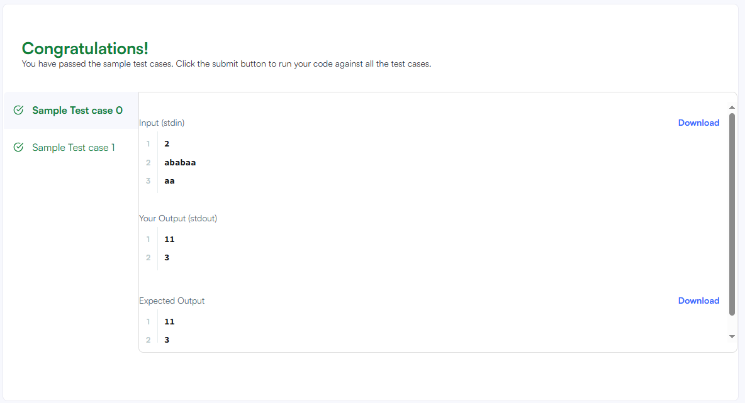

Task2
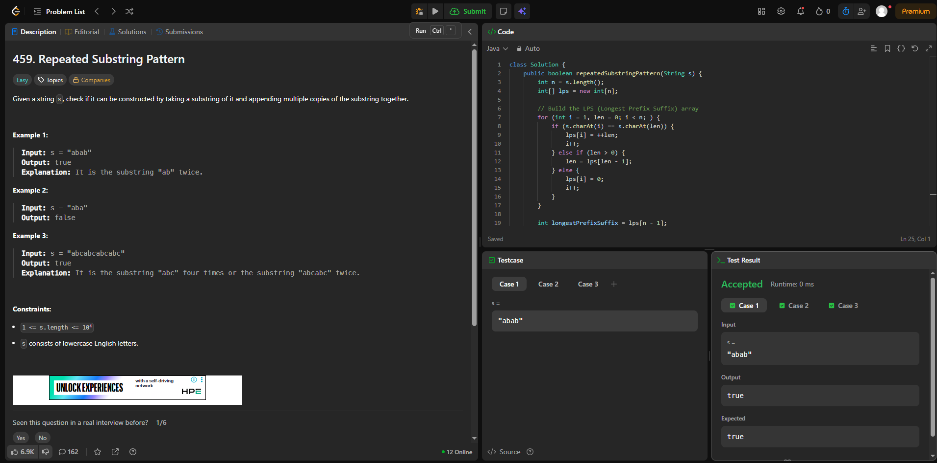
Task3
Program
import java.io.*;
import java.math.*;
import java.security.*;
import java.text.*;
import java.util.*;
import java.util.concurrent.*;
import java.util.regex.*;

class Result {
public static String twoStrings(String s1, String s2) {
boolean[] present = new boolean[26];

// Store characters from s1
for (char c : s1.toCharArray()) {
present[c - 'a'] = true;
}

// Check whether s2 contains any character from s1
for (char c : s2.toCharArray()) {
if (present[c - 'a']) {
return "YES";
}
}

return "NO";
}
}

public class Solution {
public static void main(String[] args) throws IOException {
BufferedReader bufferedReader = new BufferedReader(new InputStreamReader(System.in));
BufferedWriter bufferedWriter = new BufferedWriter(new FileWriter(System.getenv("OUTPUT_PATH")));

int q = Integer.parseInt(bufferedReader.readLine().trim());

for (int qItr = 0; qItr < q; qItr++) {
String s1 = bufferedReader.readLine();

String s2 = bufferedReader.readLine();

String result = Result.twoStrings(s1, s2);

bufferedWriter.write(result);
bufferedWriter.newLine();
}

bufferedReader.close();
bufferedWriter.close();
}
}

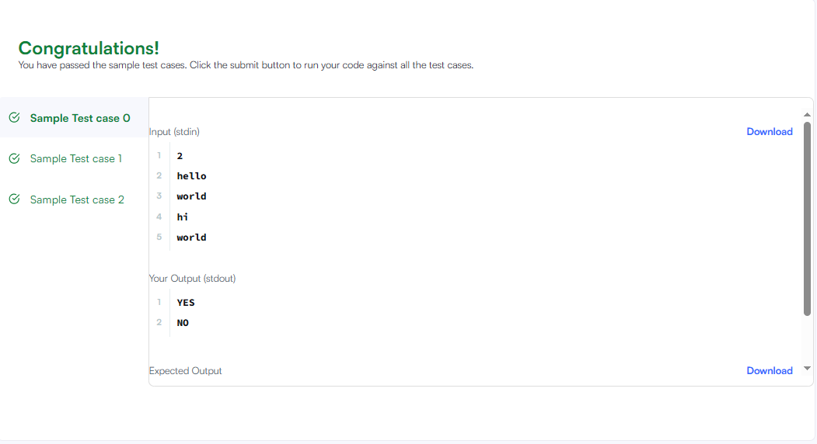
Task4
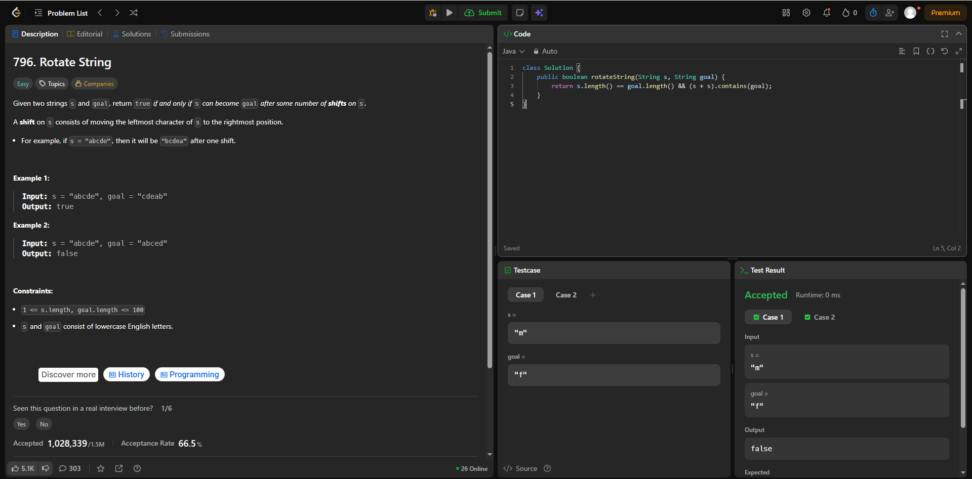
Task5
Program
import java.io.*;
import java.math.*;
import java.security.*;
import java.text.*;
import java.util.*;
import java.util.concurrent.*;
import java.util.regex.*;

class Result {

public static int marsExploration(String s) {
int changedCount = 0;

for (int i = 0; i < s.length(); i++) {
char expectedChar;

int mod = i % 3;
if (mod == 0 || mod == 2) {
expectedChar = 'S';
} else {
expectedChar = 'O';
}

if (s.charAt(i) != expectedChar) {
changedCount++;
}
}

return changedCount;
}

}

public class Solution {
public static void main(String[] args) throws IOException {
BufferedReader bufferedReader = new BufferedReader(new InputStreamReader(System.in));
BufferedWriter bufferedWriter = new BufferedWriter(new FileWriter(System.getenv("OUTPUT_PATH")));

String s = bufferedReader.readLine();

int result = Result.marsExploration(s);

bufferedWriter.write(String.valueOf(result));
bufferedWriter.newLine();

bufferedReader.close();
bufferedWriter.close();
}
}
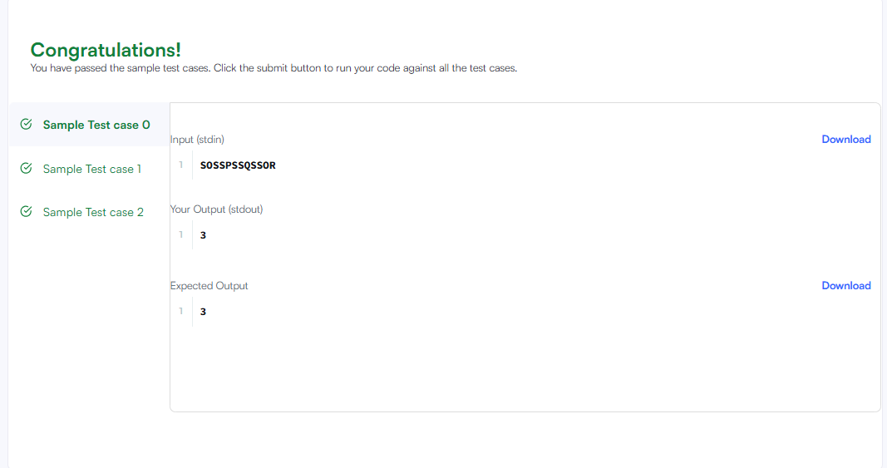

Task6

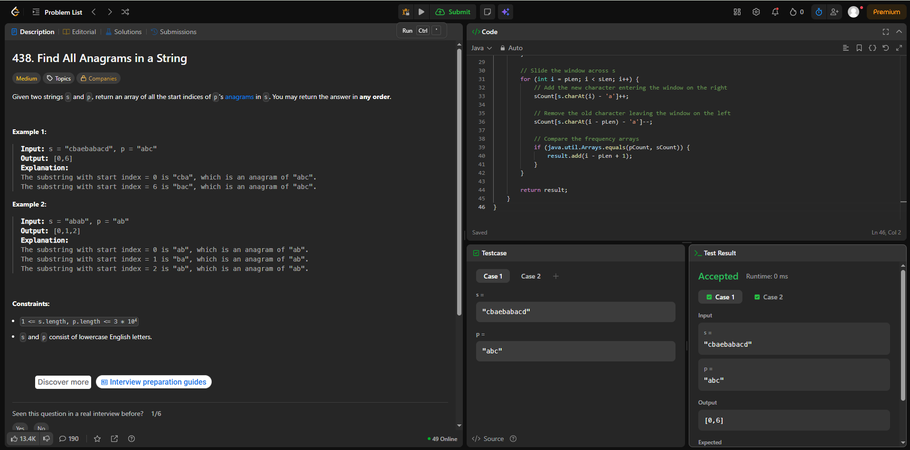
Task7
Program
import java.io.*;
import java.math.*;
import java.security.*;
import java.text.*;
import java.util.*;
import java.util.concurrent.*;
import java.util.regex.*;

class Result {
public static int palindromeIndex(String s) {
int left = 0;
int right = s.length() - 1;

while (left < right) {
if (s.charAt(left) == s.charAt(right)) {
left++;
right--;
} else {
if (isPalindrome(s, left + 1, right)) {
return left;
}
if (isPalindrome(s, left, right - 1)) {
return right;
}

return -1;
}
}

return -1;
}
private static boolean isPalindrome(String s, int left, int right) {
while (left < right) {
if (s.charAt(left) != s.charAt(right)) {
return false;
}
left++;
right--;
}
return true;
}

}

public class Solution {
public static void main(String[] args) throws IOException {
BufferedReader bufferedReader = new BufferedReader(new InputStreamReader(System.in));
BufferedWriter bufferedWriter = new BufferedWriter(new FileWriter(System.getenv("OUTPUT_PATH")));

int q = Integer.parseInt(bufferedReader.readLine().trim());

for (int qItr = 0; qItr < q; qItr++) {
String s = bufferedReader.readLine();

int result = Result.palindromeIndex(s);

bufferedWriter.write(String.valueOf(result));
bufferedWriter.newLine();
}

bufferedReader.close();
bufferedWriter.close();
}
}

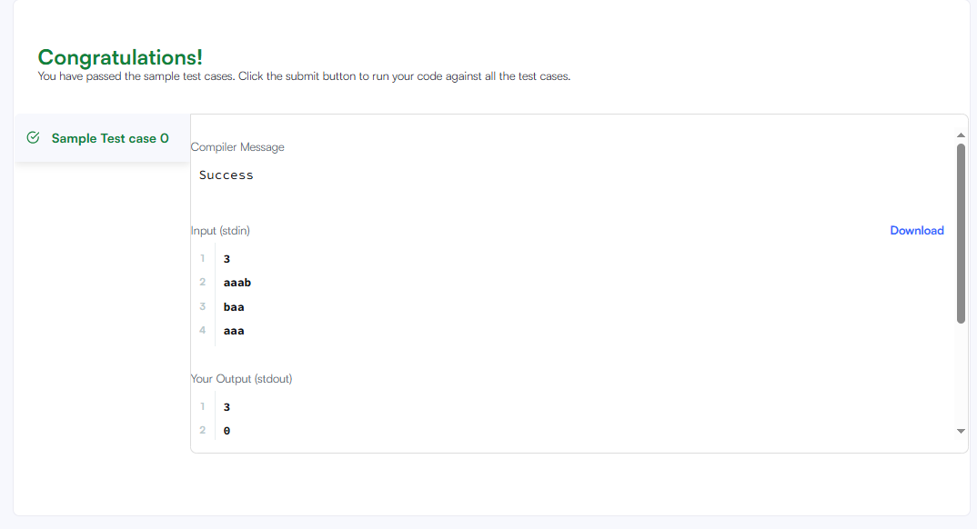
Task8
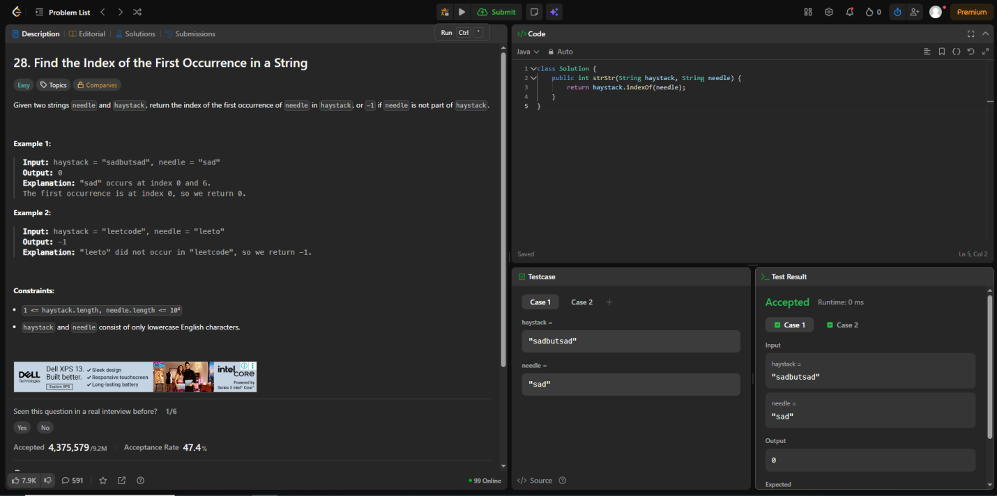

Task9
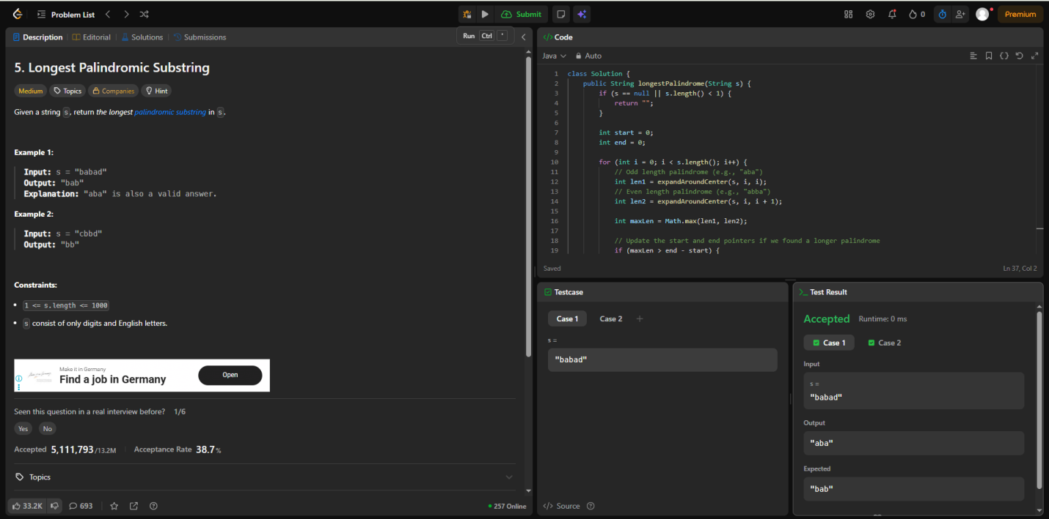
Task10
import java.io.*;
import java.math.*;
import java.security.*;
import java.text.*;
import java.util.*;
import java.util.concurrent.*;
import java.util.regex.*;

class Result {
public static List<Integer> circularPalindromes(String s) {
int n = s.length();
String t = s + s.substring(0, n - 1);
int m = t.length();
int[] odd = new int[m];

int l = 0, r = -1;

for (int i = 0; i < m; i++) {
int k = (i > r) ? 1 : Math.min(odd[l + r - i], r - i + 1);

while (i - k >= 0 &&
i + k < m &&
t.charAt(i - k) == t.charAt(i + k)) {
k++;
}

odd[i] = k;

if (i + k - 1 > r) {
l = i - k + 1;
r = i + k - 1;
}
}
int[] even = new int[m];

l = 0;
r = -1;

for (int i = 0; i < m; i++) {
int k = (i > r) ? 0 : Math.min(even[l + r - i + 1], r - i + 1);

while (i - k - 1 >= 0 &&
i + k < m &&
t.charAt(i - k - 1) == t.charAt(i + k)) {
k++;
}

even[i] = k;

if (i + k - 1 > r) {
l = i - k;
r = i + k - 1;
}
}
int[] ans = new int[n];
int[] leftBest = new int[m + 1];
int[] rightBest = new int[m + 1];
int size = 1;
while (size < n) {
size <<= 1;
}

int[] tree = new int[size << 1];
for (int center = 0; center < m; center++) {
int rad = odd[center];

if (rad <= 0) continue;
int left = center - rad + 1;
int right = center + rad - 1;
int len = 2 * rad - 1;
if (len > n) {
rad = (n + 1) / 2;
left = center - rad + 1;
right = center + rad - 1;
len = 2 * rad - 1;
}
int lo = Math.max(0, right - n + 1);
int hi = Math.min(n - 1, left);

if (lo <= hi) {
rangeChMax(tree, size, lo, hi, len);
}
if (left >= 0 && left < m) {
leftBest[left] = Math.max(leftBest[left], len);
}

if (right >= 0 && right < m) {
rightBest[right] = Math.max(rightBest[right], len);
}
}
for (int center = 0; center < m; center++) {
int rad = even[center];

if (rad <= 0) continue;

int left = center - rad;
int right = center + rad - 1;
int len = 2 * rad;

if (len > n) {
rad = n / 2;
left = center - rad;
right = center + rad - 1;
len = 2 * rad;
}

if (len <= 0) continue;

int lo = Math.max(0, right - n + 1);
int hi = Math.min(n - 1, left);

if (lo <= hi) {
rangeChMax(tree, size, lo, hi, len);
}

if (left >= 0 && left < m) {
leftBest[left] = Math.max(leftBest[left], len);
}

if (right >= 0 && right < m) {
rightBest[right] = Math.max(rightBest[right], len);
}
}
for (int i = 1; i < m; i++) {
leftBest[i] = Math.max(leftBest[i], leftBest[i - 1] - 2);
}
for (int i = m - 2; i >= 0; i--) {
rightBest[i] = Math.max(rightBest[i], rightBest[i + 1] - 2);
}
for (int start = 0; start < n; start++) {
int value = pointQuery(tree, size, start);
value = Math.max(value, leftBest[start]);
value = Math.max(value, rightBest[start + n - 1]);
ans[start] = Math.max(value, 1);
}

List<Integer> result = new ArrayList<>(n);

for (int x : ans) {
result.add(x);
}

return result;
}
private static void rangeChMax(
int[] tree,
int size,
int left,
int right,
int value) {

left += size;
right += size;

while (left <= right) {
if ((left & 1) == 1) {
tree[left] = Math.max(tree[left], value);
left++;
}

if ((right & 1) == 0) {
tree[right] = Math.max(tree[right], value);
right--;
}

left >>= 1;
right >>= 1;
}
}
private static int pointQuery(int[] tree, int size, int pos) {
int result = 1;

int node = pos + size;

while (node > 0) {
result = Math.max(result, tree[node]);
node >>= 1;
}

return result;
}
}

public class Solution {
public static void main(String[] args) throws IOException {
BufferedReader bufferedReader = new BufferedReader(new InputStreamReader(System.in));
BufferedWriter bufferedWriter = new BufferedWriter(new FileWriter(System.getenv("OUTPUT_PATH")));

int n = Integer.parseInt(bufferedReader.readLine().trim());

String s = bufferedReader.readLine();

List<Integer> result = Result.circularPalindromes(s);

for (int i = 0; i < result.size(); i++) {
bufferedWriter.write(String.valueOf(result.get(i)));

if (i != result.size() - 1) {
bufferedWriter.write("\n");
}
}

bufferedWriter.newLine();

bufferedReader.close();
bufferedWriter.close();
}
}

